HW3

Chunmei Sun

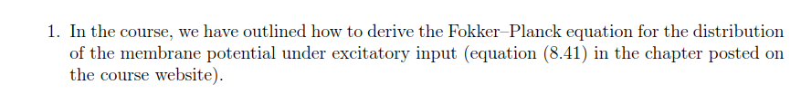



**Answer**:

$P^{trans}\left(u,t+∆t|u^{'},t\right)=\left[1-∆t*\sum_{k}{v_{k}\left(t\right)}\right]δ\left(u-u'e^{-\frac{∆t}{τ_{m}}}\right)+∆t\sum_{k}{v_{k}\left(t\right)}δ\left(u-u^{'}e^{-\frac{∆t}{τ_{m}}}-ω_{k}\right)$ Eq1

Since

$p\left(u,t+∆t\right)=\int{P^{trans}\left(u,t+∆t|u^{'},t\right)p\left(u',t\right)du'}$ Eq2

Insert Eq1 into Eq2

$$p\left(u,t+∆t\right)=\int{\left[1-∆t*\sum_{k}{v_{k}\left(t\right)}\right]δ\left(u-u^{'}e^{-\frac{∆t}{τ_{m}}}\right)+∆t\sum_{k}{v_{k}\left(t\right)}δ\left(u-u^{'}e^{-\frac{∆t}{τ_{m}}}-ω_{k}\right)p\left(u^{'},t\right)du^{'}}$$

$$p\left(u,t+∆t\right)=\left[1-∆t*\sum_{k}{v_{k}\left(t\right)}\right]\int{δ\left(u-u^{'}e^{-\frac{∆t}{τ_{m}}}\right)p\left(u^{'},t\right)du^{'}}+∆t\sum_{k}{v_{k}\left(t\right)}\int{δ\left(u-u^{'}e^{-\frac{∆t}{τ_{m}}}-ω_{k}\right)p\left(u^{'},t\right)du^{'}}$$

$$p\left(u,t+∆t\right)=\left[1-∆t*\sum_{k}{v_{k}\left(t\right)}\right]e^{\frac{∆t}{τ_{m}}}\int{δ\left(e^{\frac{∆t}{τ_{m}}}u-u^{'}\right)p\left(u^{'},t\right)du^{'}}+∆t\sum_{k}{v_{k}\left(t\right)}e^{\frac{∆t}{τ_{m}}}\int{δ\left(e^{\frac{∆t}{τ_{m}}}u-u^{'}-{e^{\frac{∆t}{τ_{m}}}ω}_{k}\right)p\left(u^{'},t\right)du^{'}}$$

$$p\left(u,t+∆t\right)=\left[1-∆t*\sum_{k}{v_{k}\left(t\right)}\right]e^{\frac{∆t}{τ_{m}}}\int{δ\left(u^{'}-e^{\frac{∆t}{τ_{m}}}u\right)p\left(u^{'},t\right)du^{'}}+∆t\sum_{k}{v_{k}\left(t\right)}e^{\frac{∆t}{τ_{m}}}\int{δ\left(u^{'}-e^{\frac{∆t}{τ_{m}}}u+{e^{\frac{∆t}{τ_{m}}}ω}_{k}\right)p\left(u^{'},t\right)du^{'}}$$

$p\left(u,t+∆t\right)=\left[1-∆t*\sum_{k}{v_{k}\left(t\right)}\right]e^{\frac{∆t}{τ_{m}}}*p\left(e^{\frac{∆t}{τ_{m}}}u, t\right)+∆t\sum_{k}{v_{k}\left(t\right)}e^{\frac{∆t}{τ_{m}}}*p\left(e^{\frac{∆t}{τ_{m}}}u-{e^{\frac{∆t}{τ_{m}}}ω}_{k}, t\right)$ Eq3

$$p\left(u,t+∆t\right)=e^{\frac{∆t}{τ_{m}}}\left\{p\left(e^{\frac{∆t}{τ_{m}}}u, t\right)+∆t\sum_{k}{v_{k}\left(t\right)}\left[p\left(e^{\frac{∆t}{τ_{m}}}u-{e^{\frac{∆t}{τ_{m}}}ω}_{k}, t\right)\right]\right\}$$

$e^{\frac{∆t}{τ_{m}}}$ Taylor expansion

$$e^{\frac{∆t}{τ_{m}}}=1+\frac{∆t}{τ_{m}}+…≈1$$

$$p\left(e^{\frac{∆t}{τ_{m}}}u, t\right)≈p\left(u+\frac{∆t}{τ_{m}}u, t\right)≈p\left(u, t\right)+\frac{∆t}{τ_{m}}u\frac{∂}{∂u}p\left(u, t\right)$$

$$p\left(e^{\frac{∆t}{τ_{m}}}u-{e^{\frac{∆t}{τ_{m}}}ω}_{k}, t\right)≈p\left(u-ω_{k}, t\right)+\frac{∆t}{τ_{m}}u\frac{∂}{∂u}p\left(u-ω_{k}, t\right)$$

$$p\left(u,t+∆t\right)≈p\left(u, t\right)+\frac{∆t}{τ_{m}}u\frac{∂}{∂u}p\left(u, t\right)+∆t\sum_{k}{v_{k}\left(t\right)}\left[p\left(u-ω_{k}, t\right)-p\left(u, t\right)+\frac{∆t}{τ_{m}}u\frac{∂}{∂u}p\left(u-ω_{k}, t\right)-\frac{∆t}{τ_{m}}u\frac{∂}{∂u}p\left(u-ω_{k}, t\right)\right]$$

$∆t$ is small

$$p\left(u,t+∆t\right)≈\frac{∆t}{τ_{m}}p\left(u, t\right)+\frac{∆t}{τ_{m}}u\frac{∂}{∂u}p\left(u, t\right)+∆t\sum_{k}{v_{k}\left(t\right)}\left[p\left(u-ω_{k}, t\right)-p\left(u, t\right)\right]$$

$\frac{p\left(u,t+∆t\right)-p\left(u,t\right)}{∆t}=\frac{1}{τ_{m}}u\frac{∂}{∂u}p\left(u,t\right)+\sum_{k}{v_{k}\left(t\right)}\left[p\left(u-ω_{k},t\right)-p\left(u,t\right)\right]$ Eq4

$$p\left(u-ω_{k}, t\right)-p\left(u, t\right)≈-ω_{k}\frac{∂}{∂u}p\left(u,t\right)+\frac{1}{2}{ω_{k}}^{2}\frac{∂^{2}}{∂u^{2}}p\left(u,t\right)$$

$$τ_{m}\frac{∂}{∂t}=u\frac{∂}{∂u}p\left(u,t\right)-τ_{m}\sum_{k}{v_{k}\left(t\right)ω_{k}}\frac{∂}{∂u}p\left(u,t\right)+\frac{1}{2}\sum_{k}{v_{k}\left(t\right)ω_{k}^{2}}\frac{∂^{2}}{∂u^{2}}p\left(u,t\right)$$

If the $ω_{k}$ is small, then

$$τ_{m}\frac{∂}{∂u}p\left(u,t\right)=-\frac{∂}{∂u}\left[-u+τ_{m}\sum_{k}{v_{k}\left(t\right)ω_{k}}\right]p\left(u,t\right)+\frac{1}{2}\left[τ_{m}\sum_{k}{v_{k}\left(t\right)ω_{k}^{2}}\right]\frac{∂^{2}}{∂u^{2}}p\left(u,t\right)$$

Done.



**Answer**:

Insert the Eq (8.45) into Eq (8.41).

$p\left(u, t\right)=\frac{1}{\sqrt{2π〈∆u^{2}\left(t\right)〉}}exp\left\{-\frac{{\left[u\left(t|\hat{t}\right)-u_{0}(t)\right]}^{2}}{2〈∆u^{2}\left(t\right)〉}\right\}$ Eq 8.45

$$τ_{m}\frac{∂}{∂u}\frac{1}{\sqrt{2π〈∆u^{2}\left(t\right)〉}}exp\left\{-\frac{{\left[u\left(t|\hat{t}\right)-u_{0}(t)\right]}^{2}}{2〈∆u^{2}\left(t\right)〉}\right\}=-\frac{∂}{∂u}\left[-u+τ_{m}\sum_{k}{v_{k}\left(t\right)ω_{k}}\right]\frac{1}{\sqrt{2π〈∆u^{2}\left(t\right)〉}}exp\left\{-\frac{{\left[u\left(t|\hat{t}\right)-u_{0}\left(t\right)\right]}^{2}}{2〈∆u^{2}\left(t\right)〉}\right\}+\frac{1}{2}\left[τ_{m}\sum_{k}{v_{k}\left(t\right)ω_{k}^{2}}\right]\frac{∂^{2}}{∂u^{2}}\frac{1}{\sqrt{2π〈∆u^{2}\left(t\right)〉}}exp\left\{-\frac{{\left[u\left(t|\hat{t}\right)-u_{0}\left(t\right)\right]}^{2}}{2〈∆u^{2}\left(t\right)〉}\right\}=0$$

Eq. (8.45) is a solution of the equation with free boundary conditions.

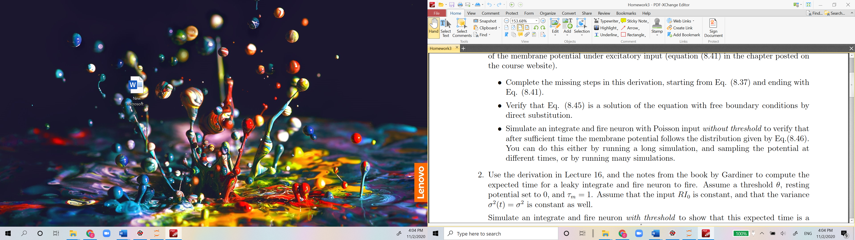

See the python code in another file

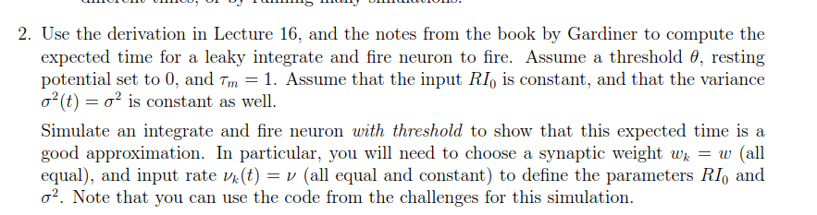

**Answer**:

Assume that:

Θ=5, ω=0.2, v0=1, k=25

Then,

$$RI_{0}=\sum_{k}{v_{0}ω}=5$$

$$σ^{2}=\sum_{k}{v_{0}ω^{2}}=1$$

$$A\left(u\right)=-u+RI_{0}$$

$$B\left(u\right)=σ^{2}$$

Also assume that initial condition x=0.2,

Based on the Eq (5.2.157) and Eq (5.2.158) from Gardiner’s book,

$$Ψ\left(u\right)=exp\left\{\int_{a}^{u}{du'\left[2A\left(u'\right)/B\left(u'\right)\right]}\right\}=exp\left\{\int_{a}^{u}{du'\left[2(-u+RI_{0})/σ^{2}\right]}\right\}=exp\left(\frac{2RI_{0}}{σ^{2}}\left(u-a\right)-\frac{1}{σ^{2}}\left(u^{2}-a\right)\right)=exp⁡(10u-u^{2})$$

$$\int_{a}^{x}{\frac{dy}{Ψ\left(y\right)}}=\int_{0}^{0.2}{exp\left(-10y+y^{2}\right)dy}≈0.0871195$$

$$\int_{x}^{b}{\frac{dy}{Ψ\left(y\right)}}=\int_{0.2}^{5}{exp\left(-10y+y^{2}\right)dy}≈0.0150146$$

$$\int_{a}^{b}{\frac{dy}{Ψ\left(y\right)}}=\int_{0}^{5}{exp\left(-10y+y^{2}\right)dy}≈0.102134$$

$$\int_{x}^{b}{\frac{dy'}{Ψ\left(y'\right)}}\int_{a}^{y'}{\frac{dzΨ\left(z\right)}{B\left(z\right)}}=\int_{0.2}^{5}{\frac{dy'}{exp⁡(10y^{'}-{y^{'}}^{2})}}\int_{0}^{y'}{\frac{dz(exp⁡(10z-z^{2})}{1}}=1.27899$$

$$\int_{a}^{x}{\frac{dy'}{Ψ\left(y'\right)}}\int_{a}^{y'}{\frac{dzΨ\left(z\right)}{B\left(z\right)}}=\int_{0}^{0.2}{\frac{dy'}{exp⁡(10y^{'}-{y^{'}}^{2})}}\int_{0}^{y'}{\frac{dz(exp⁡(10z-z^{2})}{1}}=0.0114628$$

$$T\left(x\right)=\frac{2*\left[\left(\int_{a}^{x}{\frac{dy}{Ψ\left(y\right)}}\right)\int_{x}^{b}{\frac{dy'}{Ψ\left(y'\right)}}\int_{a}^{y'}{\frac{dzΨ\left(z\right)}{B\left(z\right)}}-\left(\int_{x}^{b}{\frac{dy}{Ψ\left(y\right)}}\right)\int_{a}^{x}{\frac{dy'}{Ψ\left(y'\right)}}\int_{a}^{y'}{\frac{dzΨ\left(z\right)}{B\left(z\right)}}\right]}{\int_{a}^{b}{\frac{dy}{Ψ\left(y\right)}}}=\frac{2*(0.0871195*1.27899-0.102134*0.0114628)}{0.102134}≈2.16$$

So, the first passage time is 2.16

Python code for the simulation in another file





**Answer**:

The mean of the Gamma distribution $Γ\left(α,β\right)$ is $\frac{α}{β}$

The standard deviation of the Gamma distribution $Γ\left(α,β\right)$ is $\frac{\sqrt{α}}{β}$

Therefore, the coefficient of variation of the inter-spike interval is ${\frac{α}{β}}/{\frac{\sqrt{α}}{β}}=\sqrt{α}$

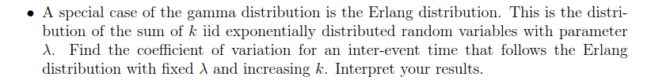

**Answer**:

The mean of the Erlang distribution $f\left(x;k,λ\right)$ is $\frac{k}{λ}$

The standard deviation of the Erlang distribution $f\left(x;k,λ\right)$ is $\frac{\sqrt{k}}{λ}$

Therefore, the coefficient of variation of the inter-spike interval is ${\frac{k}{λ}}/{\frac{\sqrt{k}}{λ}}=\sqrt{k}$

That means is the number of variables increase, the coefficient of variation will increase.

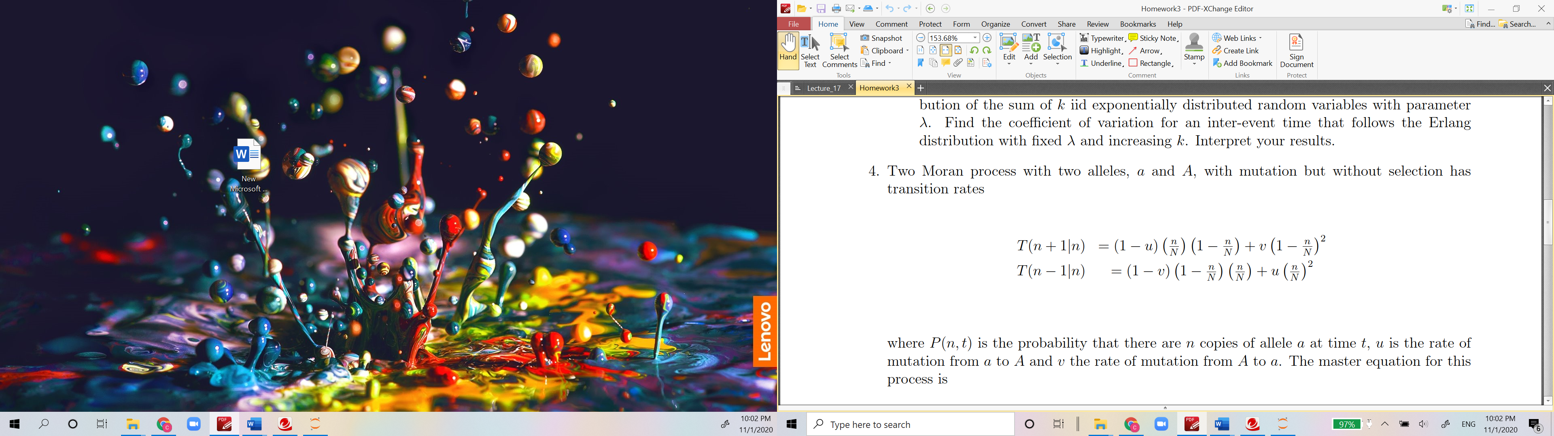

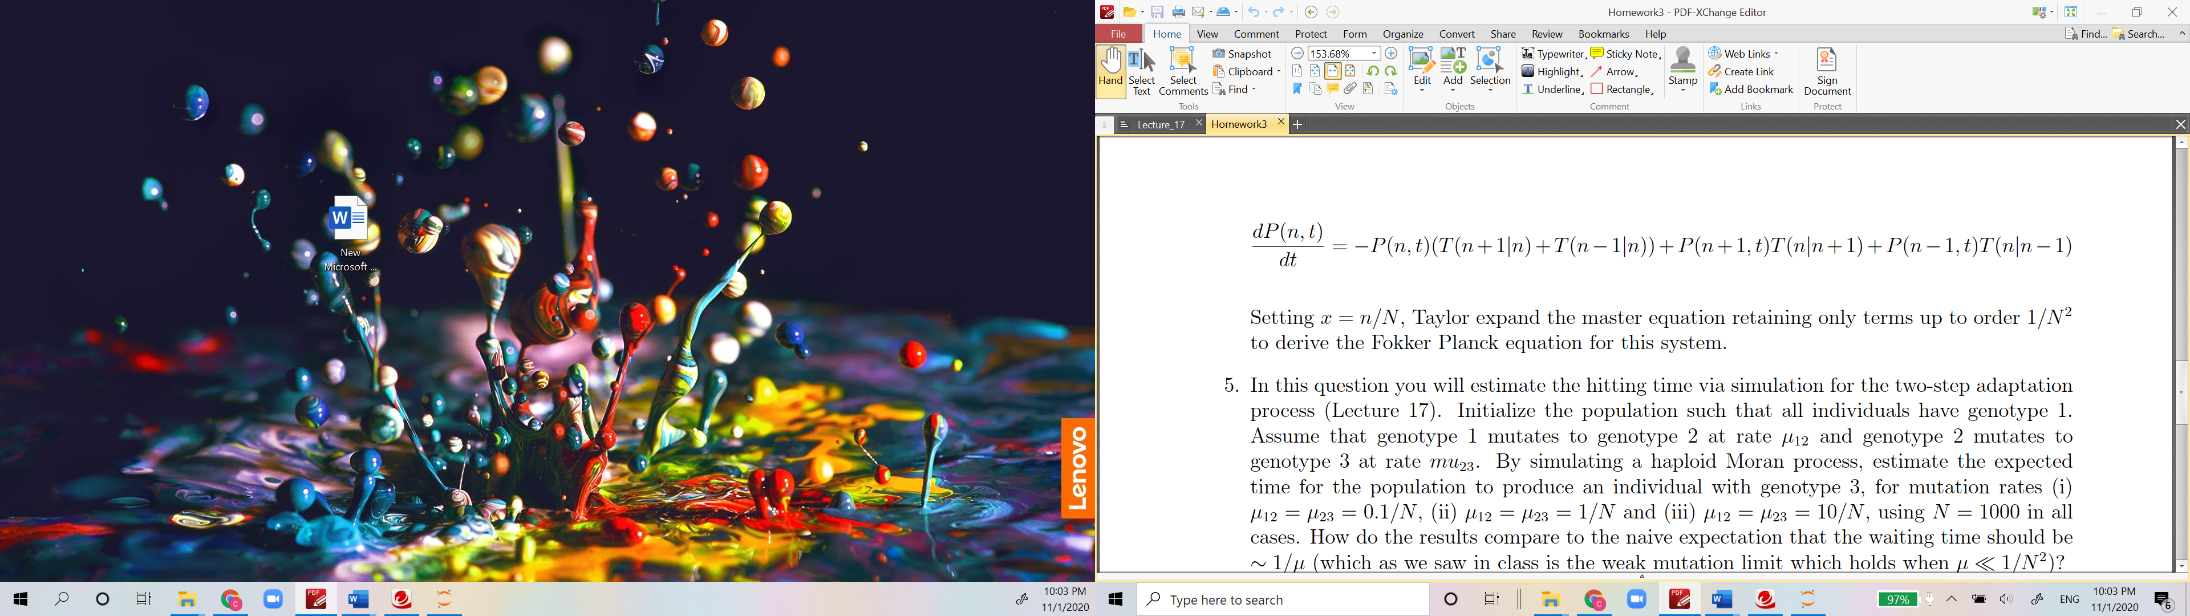

**Answer**:

Define $x=n/N$, transitions under Moran are:

$$T\left(n+1 | n\right)=T(x+1/N|x)=(1-u)x(1-x)+v{(1-x)}^{2}$$

$$T\left(n-1 | n\right)=T(x-1/N|x)=(1-v)(1-x)x+ux^{2}$$

so

$$T\left(n | n+1\right)=T(x|x+1/N)=(1-u)(x+1/N)(1-x-1/N)+v{(1-x-1/N)}^{2}$$

$$T\left(n | n-1\right)=T(x|x-1/N)=(1-v)(1-x+1/N)(x-1/N)+u{(x-1/N)}^{2}$$

For the probability distribution Taylor expand in 1/N

$$P\left(n+1, t\right)=P\left(x+\frac{1}{N}, t\right)=P\left(x, t\right)+\frac{1}{N}\frac{∂P}{∂x}+\frac{1}{2N^{2}}\frac{∂^{2}P}{∂x^{2}}$$

$$P\left(n-1, t\right)=P\left(x-\frac{1}{N}, t\right)=P\left(x, t\right)-\frac{1}{N}\frac{∂P}{∂x}+\frac{1}{2N^{2}}\frac{∂^{2}P}{∂x^{2}}$$

From the master equation

$$\frac{∂P}{∂t}=-P\left(T\left(n+1 | n\right)+T\left(n-1 | n\right)\right)+P\left(n+1, t\right)T\left(n | n+1\right)+P\left(n-1, t\right)T\left(n | n-1\right)=-P\left(\left(1-u\right)x\left(1-x\right)+v{\left(1-x\right)}^{2}+\left(1-v\right)\left(1-x\right)x+ux^{2}\right)+\left(P+\frac{1}{N}\frac{∂P}{∂x}+\frac{1}{2N^{2}}\frac{∂^{2}P}{∂x^{2}}\right)\left(\left(1-u\right)\left(x+\frac{1}{N}\right)\left(1-x-\frac{1}{N}\right)+v{\left(1-x-\frac{1}{N}\right)}^{2}\right)+\left(P-\frac{1}{N}\frac{∂P}{∂x}+\frac{1}{2N^{2}}\frac{∂^{2}P}{∂x^{2}}\right)\left(\left(1-v\right)\left(1-x+\frac{1}{N}\right)\left(x-\frac{1}{N}\right)+u{\left(x-\frac{1}{N}\right)}^{2}\right)=\frac{1}{N}\frac{∂}{∂x}\left[\left(ux-v\left(1-x\right)\right)P\right]+\frac{1}{2N^{2}}\frac{∂^{2}}{∂x^{2}}\left[x\left(1-x\right)P\right]$$

Rescale time $τ=2t/N^{2}$, then

$$\frac{∂P}{∂τ}=\frac{∂}{∂x}\left[\left(\frac{uNx}{2}-vN(1-x)/2\right)P\right]+\frac{1}{2}\frac{∂^{2}}{∂x^{2}}\left[x\left(1-x\right)P\right]$$

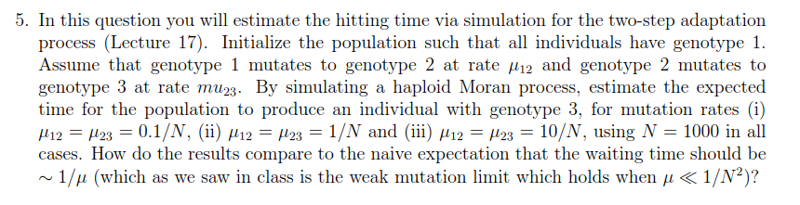

**Answer**:

Based on the two-step adaption waiting time formula

$$P\left\{T>t\right\}={\left(\frac{2}{e^{\sqrt{μ}t}+e^{-\sqrt{μ}t}}\right)}^{Nμ}$$

1. For $μ=0.1/N$ and $N=1000$, the expect waiting time is

$${\left(\frac{2}{e^{\sqrt{μ}t}+e^{-\sqrt{μ}t}}\right)}^{Nμ}={\left(\frac{2}{e^{\sqrt{0.0001}t}+e^{-\sqrt{0.0001}t}}\right)}^{0.1}=0.5$$

Solve the equation and get

$$t≈762$$

1. For $μ=1/N$ and $N=1000$, the expect waiting time is

$${\left(\frac{2}{e^{\sqrt{μ}t}+e^{-\sqrt{μ}t}}\right)}^{Nμ}={\left(\frac{2}{e^{\sqrt{0.001}t}+e^{-\sqrt{0.001}t}}\right)}^{1}=0.5$$

Solve the equation and get

$$t≈41.6$$

1. For $μ=10/N$ and $N=1000$, the expect waiting time is

$${\left(\frac{2}{e^{\sqrt{μ}t}+e^{-\sqrt{μ}t}}\right)}^{Nμ}={\left(\frac{2}{e^{\sqrt{0.01}t}+e^{-\sqrt{0.01}t}}\right)}^{10}=0.5$$

Solve the equation and get

$$t≈3.8$$

Compare the results with the naïve expectation time, which are $1/μ$, ( $t=10000$ for case 1, $t=1000$ for case 2 and $t=100$ for case 3), the waiting time is much shorter.

Python code for the simulation in another file.